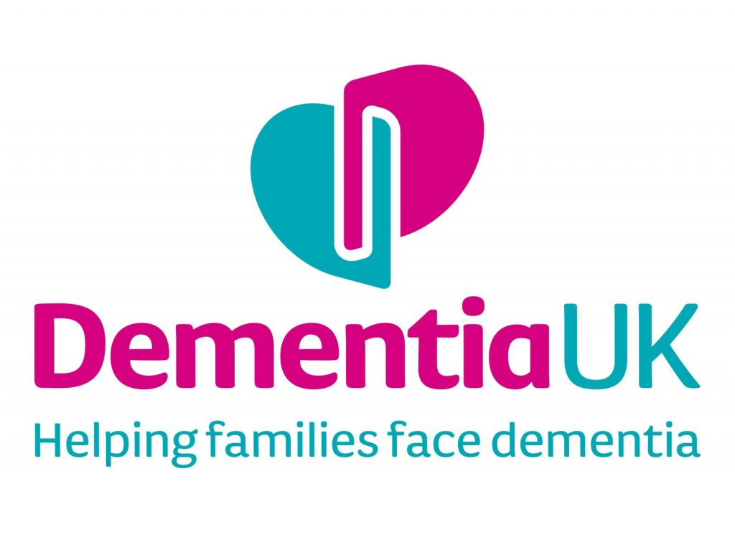
Participant information sheet

Date: 25/01/21 Version no: 3.0

In search of a good death: What would a good death in dementia look like?
We would like to invite you to take part in a project that we are currently undertaking to explore what people with dementia see as constitutes a good death in light of a diagnosis of dementia. Before you decide whether you are willing to take part, it is important for you to understand why this project is being undertaken and what it will involve. Please take time to read the following information carefully. Talk to others about it if you wish; take time to decide whether or not you would like to take part.

Background
People with other life-limiting conditions (e.g. cancer) have been asked to share their opinions on what good death and dying means to them. The results of those researchers have been important to inform better healthcare policies for patients with those diseases. To date, a good death in dementia is largely defined from a clinical perspective and often focuses on symptoms – these definitions then form a basis of national policy and guidelines. We believe it is very important to bring the voice of people living with dementia to these discussions of death and dying, and drive user-led policy development.

Why me?
You have a diagnosis of dementia and attend a local support group. We wish to recruit 8-12 people who are in this situation. We seek your opinions on what you feel constitutes a good death and dying in light of your dementia diagnosis.

Do I have to take part?
No. It is up to you to decide whether or not to take part. If you do, you will be asked to sign a consent form before proceeding further. You are still free to withdraw at any time without giving your reasons. You can also choose to withdraw the information shared with us at any time. Should you wish to do so, please get in touch using researcher contact details provided below.

What will happen if I take part?
We would like to talk to you in a place that is private and convenient for you. We will ask questions about what you consider a good death to be for people living with dementia like yourself. There are no right or wrong answers to the questions and you can talk about anything that you feel is relevant. It is possible that during the interview you may find the topics discussed sensitive or upsetting. If you do feel like this you should raise it with the interviewer immediately. You are free to ask the interviewer to move on to another subject or to terminate the interview altogether. You are not required to discuss anything that you do not want to and only the things which you feel are relevant.

What do I have to do?
An interviewer will contact you and arrange a convenient time to call you via video (any platform of your choice). The interview will last approximately one hour. You are welcome to have someone (e.g. a family member or carer) with you during the interview.

What are the possible benefits of taking part?
We hope that in taking part in this project, the information collected from you and the other participants will help to improve our understanding of what people with dementia perceive to be a good death so that better end-of-life care can be offered in the future. The benefits of having this knowledge would also inform future research.

Are there any disadvantages/risks from taking part?
There may be some inconvenience in attending an interview session. However, we consider there to be hardly any disadvantages. The session will be arranged so that it causes the least disruption and inconvenience to you. You may find discussing death and dying to be upsetting. If this should happen during the course of the interview, you can tell the interviewer to stop the interview or give you time to compose yourself, if you would prefer to continue.

What if there is a problem?
If you have a concern about any aspect of this project, you can ask to speak with the interviewer who will do their best to answer your questions (email: R.Mikelyte@kent.ac.uk; tel: 01227 823666). If you remain unhappy and wish to complain formally, you can do this through the University of Kent Complaints Procedure, please contact Professor Alisoun Milne (email: A.J.Milne@kent.ac.uk) who is not part of the study team and will address your complaint confidentially.

Will my taking part in this study be kept confidential?
Yes. We will enter information into a secure database using only pseudonyms which we will use to combine information from everyone who takes part in the study. Your name and contact details will be removed from any data that is stored concerning you or any other person you name during the interview.

The data collected for the project will remain pseudonymised. The project team will have a duty of confidentiality to you as a project participant and nothing that could reveal your identity will be disclosed outside the project site. Our procedures for handling, processing, storage and destruction of data are compliant with the General Data Protection Regulation (2018).

What will happen to the results of the study?
We hope to publish results in scientific journals and present at conferences so that the findings can be disseminated throughout the country and internationally. You will not be identified in any report/publication. A second stage of the analysis aims to compare and contrast (anonymous) participant responses internationally.

If you would like to receive a copy of a lay report on the results of the study, please provide your contact details on a separate from provided.

Who is organising and funding this project?
The project is being carried out by staff employed by the University of Kent. It is not funded by a grant or any other organisation.

Who can I contact if I have further questions?
Please contact: Dr Rasa Mikelyte, Research Assistant, Centre for Health Services Studies (CHSS) Room CGA217, Cornwallis George Allen Wing University of Kent, Canterbury CT2 7NF, tel: (01227) 823666 email: R.Mikelyte@kent.ac.uk

